HANOI UNIVERSITY OF SCIENCE AND TECHNOLOGY

**SCHOOL OF ELECTRONICS AND TELECOMMUNICATIONS**

**PROJECT REPORT**

**ANTI-THIEF ALARM**

Name of students: *ET2000E – Class 394 – Team The Boys*

Lai Thanh Thai

Bui Xuan Trung

Doan Anh Tuan Son

Ho Tuan Tu

Name of instructor: Ph.D. Assoc. Prof. Truong Thu Huong

Name of referee: ……………………………………

Hanoi, 03-2023

Table of Contents

ACKNOWLEDGEMENT 4

ABSTRACT 5

1. Introduction 6

1.1. Motivation 6

1.2. Purpose 6

2. Specification Requirements 6

2.1. Executive Summary 6

2.1.1. Project Overview 6

2.1.2. Purpose and Scope 6

2.2. Product Description 6

2.2.1. Product Context 6

2.2.2. Assumptions 7

2.2.3. Constraints 7

2.3. Requirements 7

2.3.1. Functional Requirements 7

2.3.2. Non-functional Requirements 7

3. Planning 8

3.1. Task Table 9

3.2. Human Resource Table 11

3.3. Gantt chart and Network Diagram 13

4. Block Designing 16

4.1. Inputting the signals 16

4.2. Processing the information 16

4.3. Resulting output 16

4.4. Power Source 17

5. Testing 17

6. Manufacturing 18

CONCLUSION 19

References 27

APPENDIX A - BILL OF MATERIALS A

APPENDIX B – TRANSISTOR PN2222A DATASHEET C

**ACKNOWLEDGEMENT**

In the age of the present information explosion, the applicability and the potential development of the advertising information are very big, the application of the new techniques is very necessary in this field.

We really appreciate Dr. Truong Thu Huong’s help with our project, and she created favorable conditions for our team to complete brilliantly this project.

Although we made every effort, our ability is limited. Moreover, this project is a new field for our team, so we should not avoid design errors in content and the method of presentation. Our team is looking forward to Dr. Truong Thu Huong's guidance and your additional suggestion to improve this project.

We would like to say thanks to everybody who helps us on this project!

**ABSTRACT**

Nowadays, the security situation of the residential areas has not been attached special importance, and the thief is increasing day by day. The goal of this project is to design and build an anti-thief alarm controlled by Arduino. In this report, the design of the alarm circuit to meet the specification is explained. The circuit was built using the PIR Heat Motional Sensor. The design of the anti-thief alarm was simulated in sensor to verify its performance. Then the circuit was tested on the Arduino mainly. In most cases, the objectives of the project were met. However, there should be some recommendations for further research and work.

1. **Introduction**
   1. **Motivation**

We choose this project because of some reasons:

-Alarm has lots of applications in electronic devices, mainly used for alarming, detecting that there are illegal intrusions in houses, offices…

-Anti-thief alarm can be bought easily.

-Devices and equipment are suitable for students’ economic condition.

-The project meets the needs of the subject.

-Students easily get the basic knowledge about electronics.

* 1. **Purpose**

- Understand 9 steps in the designing process.

- Know how to use several electrical equipment and designing software.

- Build a well-performed beautiful Anti-thief Alarm with low price.

1. **Specification Requirements**
   1. **Executive Summary**
      1. ***Project Overview***

Anti-thief alarm has the task of alarming, emitting signal when it detects illegal intrusions in the protected area and sending the message via our smartphone.

* + 1. ***Purpose and Scope***

This document addresses the requirements related to the designing phase of the project.

* 1. **Product Description**
     1. ***Product Context***

The product is independent and self-contained. It is not related to any other products or larger systems.

* + 1. ***Assumptions***

It is assumed that all the equipment required are available in Vietnam.

* + 1. ***Constraints***
  1. **Requirements**
     1. ***Functional Requirements***

-The product is connected to the Wi-Fi Hotspots through directly to one central router and a modem.

-The product can also connect to smartphones by Bluetooth and send message.

-The alarm goes off with the red color signal light of the LED due to the magnitude of signal of the temperature motion that it represents.

-The sound system can reach to 10m radius.

-The product should be powered by an AC/DC adapter.

* + 1. ***Non-functional Requirements***
       1. *Performance*

Delay time: less than …

* + - 1. *Appearance:* Round-shaped
      2. *Power Consumption*

-Power Supply: DC 12V/2A

-Power Consumption: 24W

* + - 1. *Development Time:* About 9 weeks
      2. *Development Cost:* Less than 500,000 VNĐ

1. **Planning**

The next phase in the project is developing plan. The project will last for only 9 weeks, so we need to create a really smart plan to finish the project on time. Firstly, we must have the Task Table and the Human Resource Table made.

* 1. **Task Table**

Our project consists of 8 tasks. In some tasks, there are sub-tasks for easier management. Each task has its own deliverables. The project starts on October 26th, 2022, and ends on March 20th, 2023.

|  |  |  |  |  |  |  |
| --- | --- | --- | --- | --- | --- | --- |
| Task  ID | Task Name | Duration | Start Date | End Date | Dependencies | Deliverables |
| #1 | Determine  needs | 3 days | October  26th | October  28th |  | Specification requirement document in Microsoft Word format (.docx) |
| #2 | Create Specifications | 2 weeks | November  2nd | November  19th |  | Specification requirement document in Microsoft Word format (.docx) |
| #3 | Develop a plan | 1 week | November  23rd | November  29th | #2 | Task Table  Human Resource Table  Plan developed in Microsoft Excel |
| #4 | Perform block design | 1 week | November  30th | December  6th | #3 | Block diagram in MS Visio Pro 2013 |
| #5 | Design each block | 2 weeks | December  21st | January  3rd,2023 | #4 |  |
|  | Inputting signals | 4 days | December 22nd | December  26th |  |  |
|  | Processing information | 4 days | December 27th | December 30th |  |  |
|  | Making output | 2 days | December 31st | January 2nd, 2023 |  |  |
|  | Displaying | 1 day | January 3rd, 2023 |  |  |  |
| #6 | Best alternative selection | 3 days | January 4th | January 7th | #5 | Select Alternatives Table |

* 1. **Human Resource Table**

Our team has 4 members. Each one has different strength and weakness. The following table will help us on assigning resources to tasks for maximum productivity.

|  |  |  |  |  |
| --- | --- | --- | --- | --- |
| **ID** | **Name** | **Strength** | **Weakness** | **Available** |
| #1 | Lai Thanh Thai | * Microsoft Office * Searching skill * Programming C | * Speaking for presentation | Weekdays |
| #2 | Ho Tuan Tu | * Speaking skill * Note-taking and writing | * Circuit designing | Weekdays |
| #3 | Bui Xuan Trung | * Microsoft Word * Drawing * Electrical components | * Programming language C/C++ | Weekdays |
| #4 | Doan Anh Tuan Son | * Presentation skills * Enthusiasm | * Circuit designing | Weekdays |

Then the team members are assigned to the tasks.

|  |  |  |
| --- | --- | --- |
| **Task ID** | **Task Name** | **Resource Name** |
| #1 | Determine needs | Tu T. Ho, Trung X. Bui and Son A.T. Doan |
| #2 | Create specification | Thai T. Lai and Tu T. Ho |
| #3 | Develop a plan | Thai T. Lai and Trung X. Bui |
| #4 | Design each block |  |
|  | Inputting signals | Tu T. Ho and Trung X. Bui |
|  | Processing information | Thai T. Lai |
|  | Making output | Trung X. Bui and Son A.T. Doan |
|  | Displaying | Son A.T. Doan |
| #5 | Best alternatives selection | Tu T. Ho and Thai T. Lai |
| #6 | Test |  |

* 1. **Gantt Chart and Block Diagram**

Microsoft Project, which comes along with the Microsoft Office Suite, is a very powerful software to create block. The software provides a lot of features that helps us manage our project.

Canva also helps us to show the schedule and set the time for everyone in our team.

From the Task Table and the Human Resource Table, we use both MP and Canva to make the project’s Gantt chart and Network Diagram.

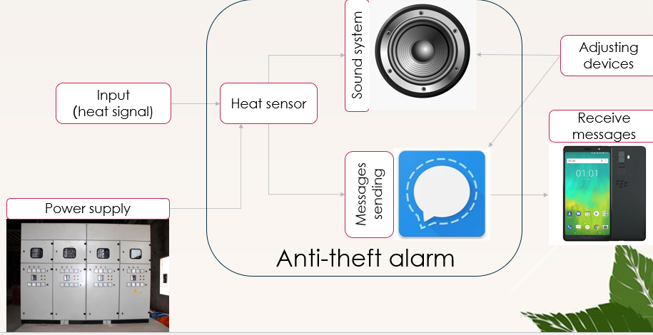

1. **Block designing**

The next phase of our project is designing the product. We made each designing block.

Resulting output

Processing the information

Inputting the signals

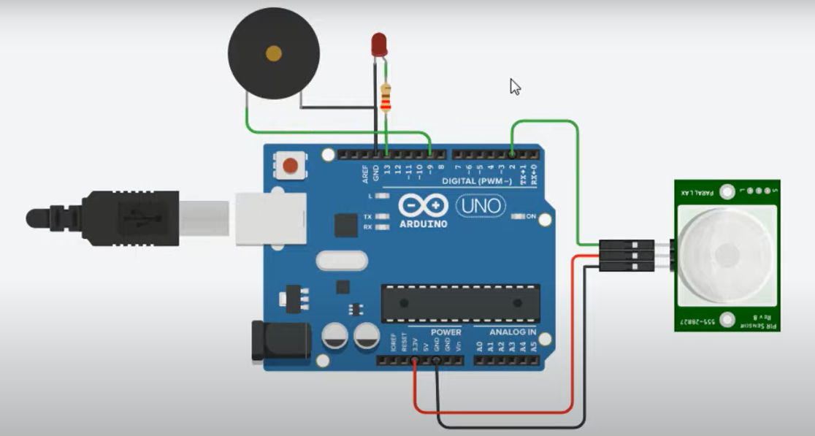

* 1. **Inputting the signal**

We use the Arduino Uno R3 to be the main component of the product.

The PIR heat motional sensor will detect the signals if there are people standing or walking through it. The sensor has 3 pins, namely the brown line connecting to 5V, the blue line connecting to ground and the black line linking to the data 3.

The red LED connects to the Arduino at data 7 and ground also, the buzzle links to the data 2 and ground.

* 1. **Processing the information**

The Arduino will receive the input signal (heat motion) and classify kinds of input whether human body’s heat or not.

* 1. **Resulting output**

The LED turns into the red color and the buzzle goes off with high frequency sound, which can make anyone panic.

The product can be auto turning off in 10 minutes.

* 1. **Power sources**

The circuit can run well with a 9V-DC voltage, but it is more efficient to use the 12V-DC. We decided to use the 12V-AC/DC adapter.

|  |  |  |  |  |  |
| --- | --- | --- | --- | --- | --- |
| Power Source | Criteria (weight) | | | | Total |
| **Voltage**  **(0.5)** | **Lifetime**  **(0.4)** | **Portability**  **(0.05)** | **Price**  **(0.05)** |
| *9V cell* | (6) | (5) | (10) | (9) | **5.95** |
| *12V cell* | (10) | (7) | (10) | (8) | **8.7** |
| *12V AC/DC Adapter* | (10) | (10) | (3) | (6) | **9.45** |

1. **Testing**

We ran the simulation for the circuit on Proteus. The simulation ran well without any errors.

1. **Manufacturing**

Demo product

**CONCLUSION**

We have built an Anti-theft Alarm that meets all the specification requirements. We now also know the 9-step designing process, as well as how to use CAD tools.

However, the alarm still do not work with the technique of transmitting the signals to the messages on our smartphone very well. Therefore, the product needs further improvements in the future.

**References**

1. Truong Thu Huong, Lecture Slides, ET2000E, 2022
2. <https://www.youtube.com/watch?v=An4BMwu62No&t=91s> (Home security system: Arduino and PIR Sensor)
3. <https://hayykel.blogspot.com/2021/08/arduino-and-pir-sensor-home-security.html> (code)
4. [Audio Visualizer] Final Report, 2015

**APPENDIX – BILL OF MATERIALS**

|  |  |  |  |
| --- | --- | --- | --- |
| Category | Quantity | Value | Unit Cost |
| Arduino Uno R3 | 1 | 5V (USB pin) | VND 230,000 |
| Buzzle | 1 | 5V | VND 4,000 |
| Red LED | 10 | 1.8-2V | VND 3,500 |
| PIR heat motional sensor | 1 | 10-30V | VND 100,000 |
| Wire box for board test | 1 |  | VND 51,000 |
| Wire 40P 20cm | 4 | Plug-plug | VND 24.000 |
| WIRE 40P 20cm | 4 | Plug-jack | VND 24,000 |